**TRIGGERS**

Q1.Write a PL/SQL trigger to restrict the insert/update/delete operations on a table.

**Program**

create table sample(sid number,sname varchar(20));

insert into sample values(&sid,'&sname');

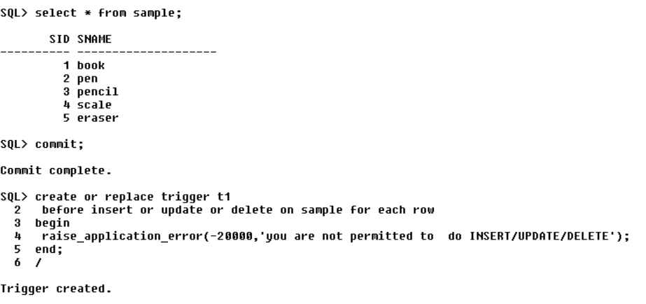

**Output**

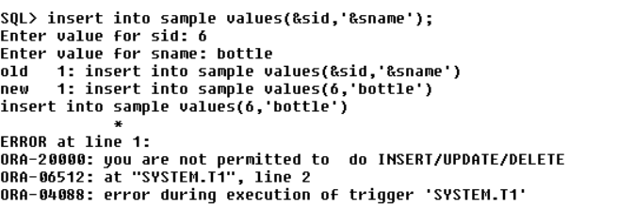

Q2.Assume our DB has a relation schema :Pfessor (pNum,pName, salary) create a trigger to ensure that any new professor inserted has salary >= 60000.

**Program**

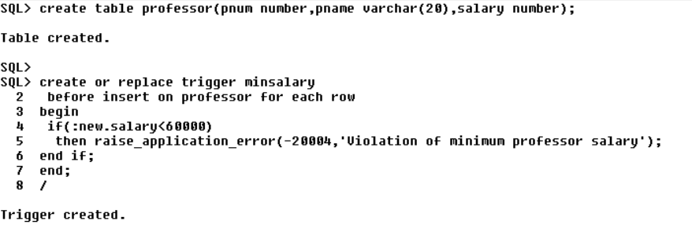

**Output**

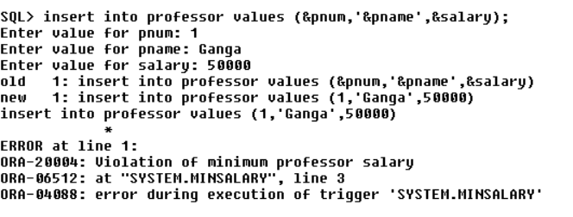

Q3.Create a backlog table for professor to store deleted professor details. Manage the operation using trigger.

**Program**

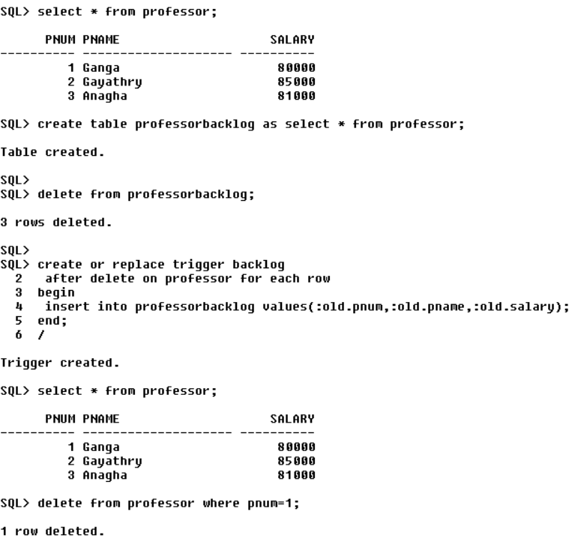

**Output**

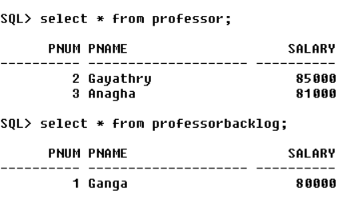

Q4.Maintain a Gold Price History table using trigger.

**Program**

create table gold(cdate date,price number);

insert into gold values('&date',&price);

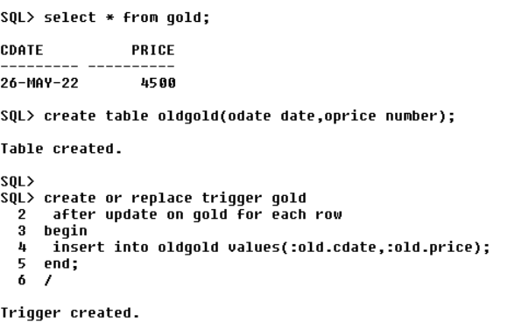

**Output**

